Personnel responsible:
Lead Operator and / or Salt Operator

Safety equipment:
All safety glasses and appropriate safety apparel is to be worn at all times.

Daily Checks
- Clean gripper head and heater bars with wet rag.  - Clean area around machine.  - Check conveyors for wear, alignment, etc.  - Clean formatting head with ink conditioner.  - Clean pinch rollers with ink conditioner  (see Weekly Cleaning instructions for more detail)  - Clean eye mark sensor  (see weekly cleaning for detailed instructions)  - Zero scales  (see Shift Checklist for detailed instructions) | 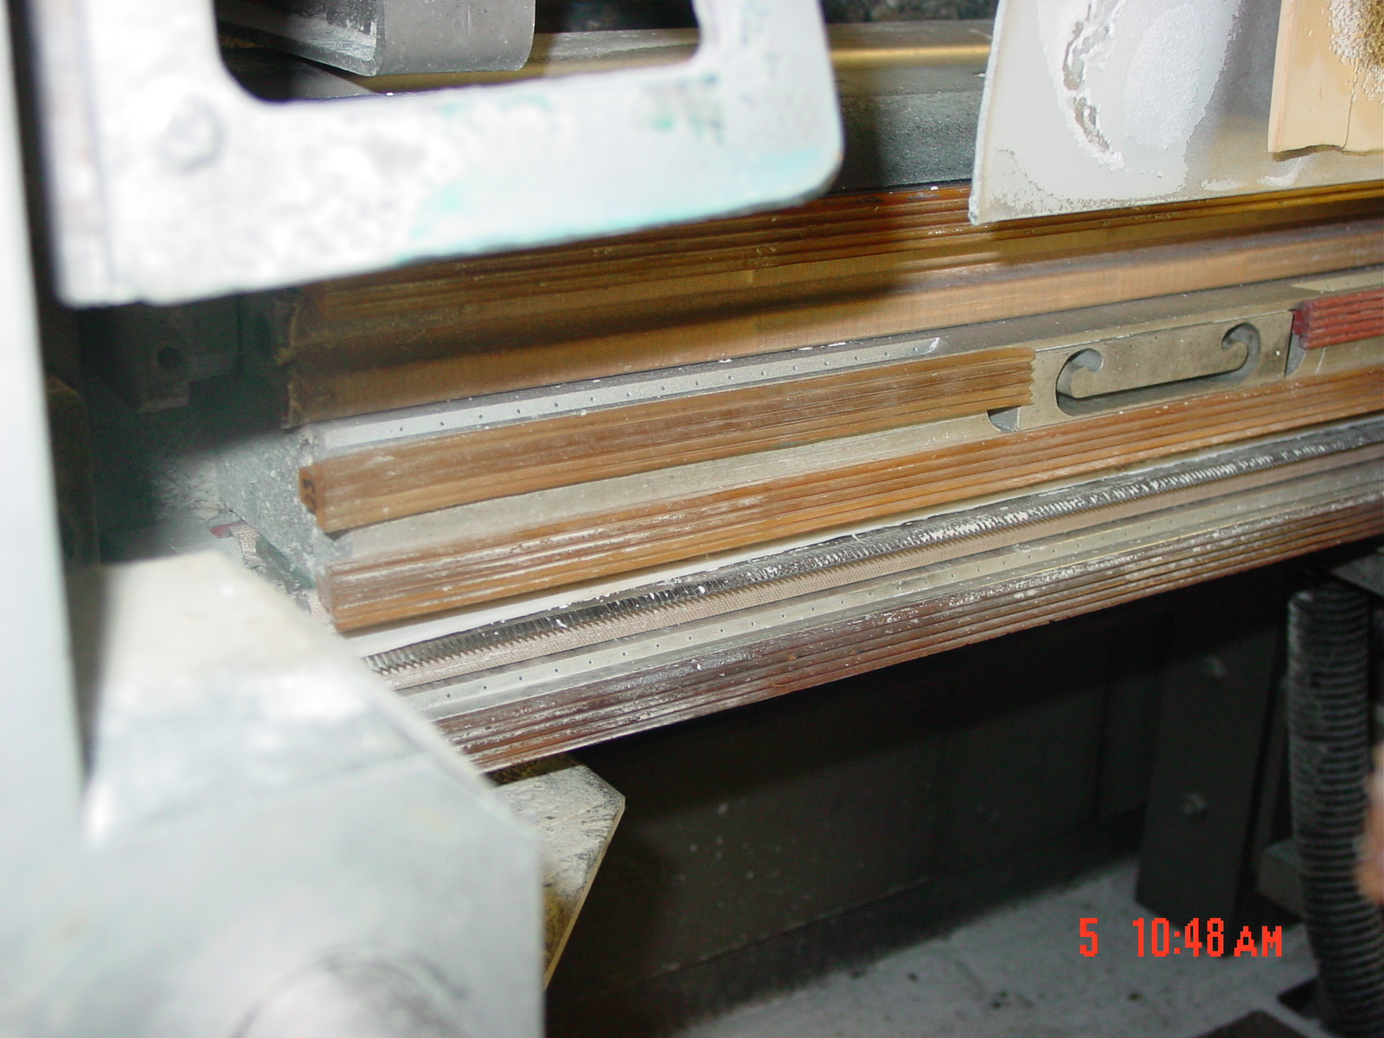  Thoroughly clean gripper strips and knife
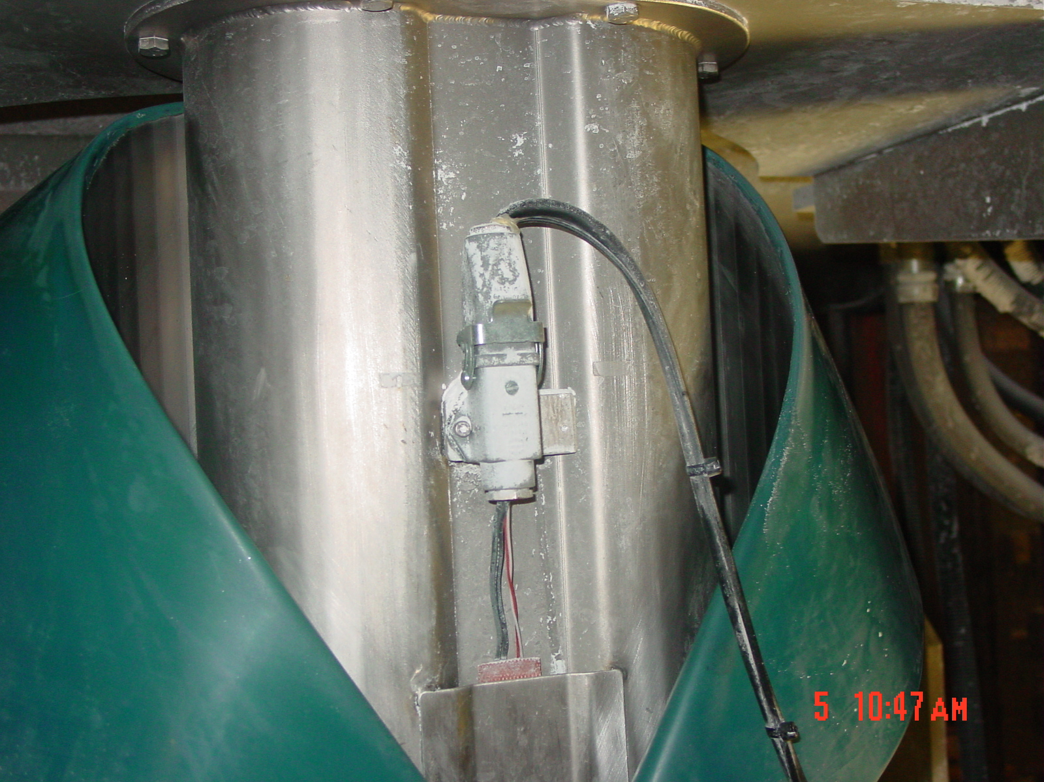
Thoroughly clean inside edge and outside of formatting head with ink conditioner

TRAINING DOCUMENTATION

 | EMPLOYEE | TITLE | SIGNATURE | DATE
1
2
3
4
5
6
7
8
9
10
11
12
13
14
15
16
17
18
19
20
21
22
23
24
25
26
27
28
29
30

Revision  Number | Revision  Date | Revision  Author | Revision Description
00 | 10/15/07 | JB | New Document
01 | 05/27/09 | JB | Updated to new Company Format

